This Week at ERC

- Kickball in the parking lot – Wednesday, July 29 from 6-7 p.m.
- Men’s Bible Study – Saturday, August 1 at 7:30 a.m. Fellowship hall

Happy Birthday This Week To:
7/26 Deb Adolph 7/26 Jasper Daniel 7/27 Harper Buikema
7/27 Mary Schaver 7/29 Courtney Bruckner 7/29 Kathi Sipes
7/31 Doris Bielema 7/31 Jane Haan 7/31 Mary Tunnacliffe

Nursery Bell Ringer:
Today - Angie Tichler & Allison Weaver Today - John Dickey
8/2 - Beth Milnes & Kinlee Prins 8/2 - Josh Gowan
Greeters: Prayer Room:
Today - Mary Schaver & Jane Haan Today - Sandi Wilkens
8/2 - Kathy V & Barb Prins 8/2 - Phil Ardapple

Welcome Center Hosts: Fellowship Hall Hosts:
Today - Sharon R & Ken Jansma Today - Arlyn & Marilyn Tichler
8/2 - Jack & Susan Bland 8/2 - Tim & Patty Bush
Offering Last Sunday: July Counting Team:
General Fund: $4,001 Jenny Patton
Organ: $7,900 Darlene Schipper

Reasons to Rejoice and Prayer Concerns
- Those who need restored health through recovery and healing: Velma Dean, Louise Wiersema, Neva Baar, Elmer Huizenga, Jeg Weets, and all those with special needs or unspoken prayer requests.
- Those in nursing/assisted living homes: Allen Buikema, Barb Geerts, Sandi Gorzney, Barney Habben, Joanne Peterson, Ruth Rosenow, Delores Stuart, Loretta Temple, Don VanDerLeest & Darlene Vos (at Resthave);
Marv Tichler (at LaBella), Bob & Irma Brands (at Homestead of Morrison); Marge Gorzny (at Allure in Prophetstown) Also: Pam Gorzny.
- Those Serving Our Country: Gregory Bush (Air Force), Brevin Pruis (Navy), Tyler Haan (Air Force), Elijah Bean (Air Force).

Order of Worship

Prelude
Ringing of the Bell
Welcome
Announcements Kathy Vanderlaan
*Opening Songs: “Jesus is All the World to Me” #510
“No One Ever Cared For Me Like Jesus”
“He Leadeth Me” #461
Symbol of Christian Faith
Responsive Reading
Prayer
Offertory: “I’d Rather Have Jesus”
Scripture Reading: Philippians 4:10-13 Pat Pessman
Message: “How to Cultivate Contentment” Pastor J.T. Bean
*Closing Song: “Just a Closer Walk With Thee” #380
*Benediction
Postlude
*stand as you are able
Song Leaders: Praise Team Organist: Deb VanZuiden
AV/Tech Team: Kayla Sipes and Jovie Patton

Welcome

Welcome to Ebenezer Church! If you have any questions about our church life, fill out our communication card and the Pastor will be in contact with you. If you have any prayer concerns that you would like to put on the prayer chain, email Pastor J.T. Bean at pastorJT@ercmorrison.com. You may also fill out the Ebenezer Communication Card on the bulletin and drop it into the offering box. Sue Bond’s email is office@ercmorrison.com. Please send bulletin announcements to this email no later than the Thursday before service. If you would like to become a church member, contact Pastor J.T. for more info.

The church OFFICE is open Monday-Friday 9am-1pm and Saturdays 7:30am-12pm.

Ebenezer Communication Card
Name:_________________________________
Address:____________________________________________
Phone:_______________ Email:______________________
[ ] I am a visitor today/new to community
[ ] I would like to join Ebenezer
[ ] I have a change of address/email/phone

Announcements

One more night of July kickball for kids of all ages. This activity will be in the parking lot Wednesday, July 29 from 6:00-7:00 p.m.

VBS is coming soon! This year it will be held at Emmanuel Church, Monday through Friday, August 3-7 from 6:00 to 8:15 p.m. each night. Register your kids or grandkids on the “Morrison Vacation Bible School” Facebook page.

The next Welcome Table dinner we are hosting at Odell Library will be Tuesday, August 4 at 5:30 p.m. Do you have an unchurched friend you can invite? Also, we are in need of more volunteers to help especially with meal preparation in the future. Contact Darlene Schipper if you are interested.

Praise the Lord, we’ve got more toddlers populating our nursery each Sunday. If you are willing volunteer once a month to care for our little ones, there is a need for a few more happy helpers! Contact the church office.

Monthly Memory Verse
Philippians 4:8 NIV
“Finally, brothers and sisters, whatever is true, whatever is
noble, whatever is right, whatever is pure, whatever is lovely, whatever is admirable – if anything is excellent or praiseworthy – think about such things.”
These five passages provide a strong biblical understanding on the theme of contentment. Look them up and meditate on them this week:
Psalm 23 — God is our sufficient Shepherd.
Matthew 6 — Trust the Father's daily provision.
Philippians 4 — Contentment in every circumstance is in Christ.
1st Timothy 6 — Contentment is true spiritual wealth.
Hebrews 13 — Contentment rests on God's abiding presence,
not material possessions.

Ebenezer Reformed Church
309 East Park Street
Morrison, Illinois 61270
815-772-2472

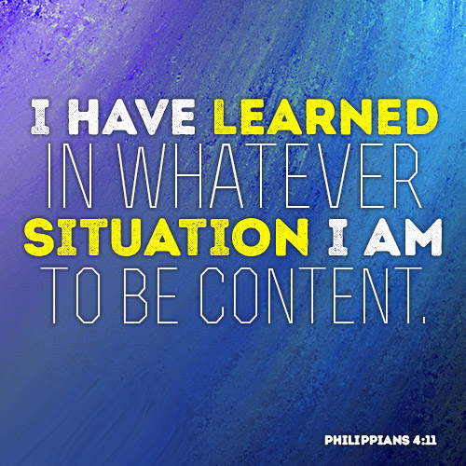

July 26, 2026
9:30 a.m.

ERC is a congregation called to intentionally share the gospel
in word and deed, as the hands, feet, and voice of Jesus Christ.
God is calling us to be a vibrant body of believers
helping people experience God’s love in Jesus Christ.
Prayer Request Slip
Fill out this short slip for anyone who needs our prayers this week.
Name and Praying for: ___________________________________________________
[ ] I will have an upcoming surgery at _____________, on this date ___________ and would like a visit ____ or call ____ from the Pastor.
Comments:

